Web Application Architecture

A Web application is usually divided into four layers:

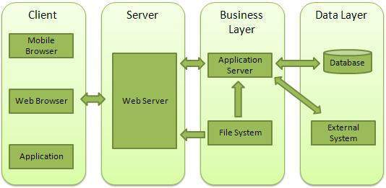

* **Client** - This layer consists of web browsers, mobile browsers or applications which can make HTTP request to the web server.
* **Server** - This layer consists of Web server which can intercepts the request made by clients and pass them the response.
* **Business** - This layer consists of application server which is utilized by web server to do required processing. This layer interacts with data layer via data base or some external programs.
* **Data** - This layer consists of databases or any source of data.